
Artificial Intelligent
LAB -8

Genetic Algorithm (GA)
What is Genetic Algorithm (GA)?
Genetic Algorithm (GA) is a metaheuristic inspired by Darwin’s theory of natural evolution. It is used to find optimal or near-optimal solutions to complex problems where traditional optimization techniques may fail or be inefficient.

Core Concepts of GA
Concept | Description
Population | A set of possible solutions (individuals or chromosomes)
Chromosome | A single solution, often represented as a binary or real-valued string
Gene | A part of a chromosome (e.g., variable or parameter)
Fitness Function | A function that evaluates how good a solution is
Selection | Choose parents based on fitness (e.g., roulette wheel, tournament)
Crossover (Recombination) | Combine two parents to produce offspring
Mutation | Randomly alter genes to maintain diversity
Elitism | Preserve the best solutions from one generation to the next

GA Workflow Steps:
- Initialize population randomly.
- Evaluate fitness of each individual.
- Select parents based on fitness.
- Apply crossover and mutation to produce new population.
- Replace old population with new generation.
- Repeat steps 2–5 until convergence or max generations.
CODE: 1
Maximize f(x) = x * sin(10πx) + 1 for x ∈ [0, 1]
Objective:
We want to find the value of x in [0,1] that maximizes this non-linear function.

MATLAB Code with Step-by-Step Explanation
clc; clear; close all;

%% Problem Definition
% Maximize f(x) = x * sin(10*pi*x) + 1 over x ∈ [0, 1]
% We use a real-coded GA (continuous values for x)

popSize = 20; % Number of individuals (solutions)
chromLength = 1; % One decision variable (x)
maxGen = 50; % Number of generations (iterations)
crossRate = 0.8; % Crossover rate (80% of individuals undergo crossover)
mutRate = 0.1; % Mutation rate (10%)

%% 🧬 Step 1: Initialize Population
% Each individual is a random number between 0 and 1
pop = rand(popSize, chromLength); % Random values of x ∈ [0, 1]

%% Step 2: Define Fitness Function
% The higher the function value, the fitter the individual
fitnessFunc = @(x) x .* sin(10 * pi * x) + 1;

% Track best fitness over generations
bestFitness = zeros(maxGen, 1);

%% Step 3: Run the GA for multiple generations
for gen = 1:maxGen
% Step 3.1: Calculate fitness for all individuals
fitness = fitnessFunc(pop); % Evaluate the objective for all x values

%% Step 3.2: Selection (Roulette Wheel)
% The fitter an individual, the more likely it will be selected
prob = fitness / sum(fitness); % Normalize probabilities
cumProb = cumsum(prob); % Cumulative probability
newPop = zeros(size(pop)); % New population (empty)
for i = 1:popSize
r = rand;
idx = find(cumProb >= r, 1, 'first'); % Select individual
newPop(i,:) = pop(idx,:);
end

%% Step 3.3: Crossover (Arithmetic Crossover)
for i = 1:2:popSize
if i+1 <= popSize && rand < crossRate
alpha = rand; % Blend factor
% Blend the two parents to create two children
temp1 = alpha * newPop(i,:) + (1 - alpha) * newPop(i+1,:);
temp2 = alpha * newPop(i+1,:) + (1 - alpha) * newPop(i,:);
newPop(i,:) = temp1;
newPop(i+1,:) = temp2;
end
end

%% Step 3.4: Mutation
% Slightly change a few genes to maintain diversity
for i = 1:popSize
if rand < mutRate
mutationValue = 0.1 * (rand - 0.5); % Small change
newPop(i,:) = newPop(i,:) + mutationValue;
% Keep the value within [0,1]
newPop(i,:) = max(0, min(1, newPop(i,:)));
end
end

%% Step 3.5: Replace population
pop = newPop;

%% Step 3.6: Record best fitness value
bestFitness(gen) = max(fitness);
end

%% Plot the Result
figure;
plot(1:maxGen, bestFitness, 'b-', 'LineWidth', 2);
xlabel('Generation');
ylabel('Best Fitness Value');
title('GA Optimization: f(x) = x sin(10πx) + 1');
grid on;
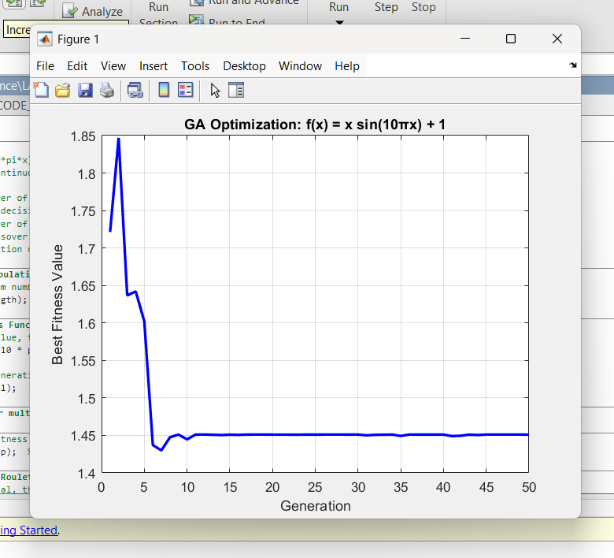

CODE: 2
Minimize Rosenbrock Function
Problem:
Minimize the Rosenbrock function:
f(x,y)=(1−x)2+100⋅(y−x2)2f(x, y) = (1 - x)^2 + 100 \cdot (y - x^2)^2
for x,y∈[−2,2]x, y \in [-2, 2]
clc; clear; close all;

%% Objective: Minimize the Rosenbrock function
popSize = 30;
dims = 2; % Two variables: x and y
pop = -2 + 4 * rand(popSize, dims); % Range: [-2, 2]
maxGen = 100;
mutRate = 0.1;

fitnessFunc = @(v) (1 - v(:,1)).^2 + 100*(v(:,2) - v(:,1).^2).^2;

bestFitness = zeros(maxGen, 1);

for gen = 1:maxGen
fitness = fitnessFunc(pop); % Lower is better

%% Selection: Roulette Wheel (invert fitness for minimization)
invFitness = 1 ./ (fitness + 1e-6);
prob = invFitness / sum(invFitness);
cumProb = cumsum(prob);
newPop = zeros(size(pop));
for i = 1:popSize
r = rand;
idx = find(cumProb >= r, 1, 'first');
newPop(i,:) = pop(idx,:);
end

%% Crossover: Single-point
for i = 1:2:popSize
if i+1 <= popSize
point = randi([1, dims]);
newPop([i, i+1], point:end) = newPop([i+1, i], point:end);
end
end

%% Mutation
for i = 1:popSize
if rand < mutRate
newPop(i,:) = newPop(i,:) + 0.1 * randn(1, dims);
newPop(i,:) = max(-2, min(2, newPop(i,:))); % Keep in range
end
end

pop = newPop;
bestFitness(gen) = min(fitnessFunc(pop));
end

%% Plotting
figure;
plot(1:maxGen, bestFitness, 'r-', 'LineWidth', 2);
xlabel('Generation'); ylabel('Best Fitness');
title('GA Minimization: Rosenbrock Function');
grid on;

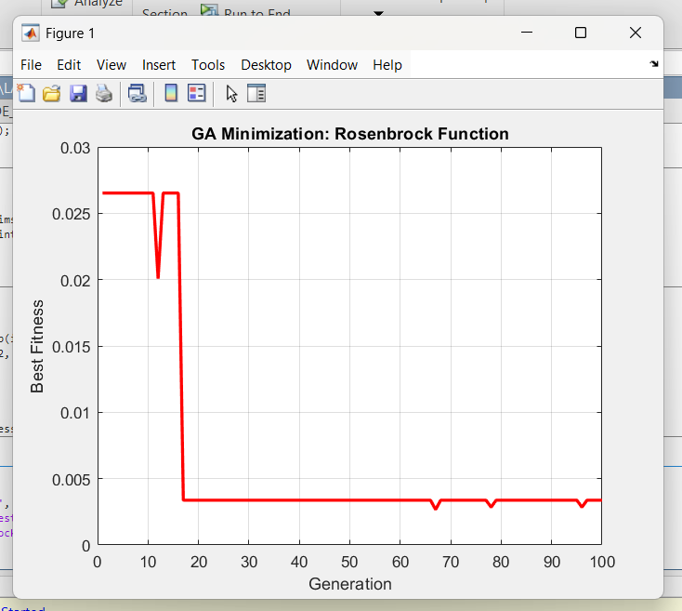

CODE: 3
Optimize Weights for Linear Regression
Problem:
Fit y = w1*x + w2 using GA to minimize MSE.
clc; clear; close all;

%% Simulated dataset
x = linspace(0, 10, 100)';
true_w = [2.5, 5]; % True slope and intercept
y = true_w(1)*x + true_w(2) + randn(size(x)); % Add noise

%% GA Settings
popSize = 30;
dims = 2; % w1 and w2
pop = -10 + 20 * rand(popSize, dims); % [-10,10] range
maxGen = 50;
mutRate = 0.1;
fitnessFunc = @(w) mean((y - (w(1)*x + w(2))).^2); % MSE

bestFitness = zeros(maxGen, 1);

for gen = 1:maxGen
fitness = zeros(popSize, 1);
for i = 1:popSize
fitness(i) = fitnessFunc(pop(i,:));
end

%% Selection
invFitness = 1 ./ (fitness + 1e-6);
prob = invFitness / sum(invFitness);
cumProb = cumsum(prob);
newPop = zeros(size(pop));
for i = 1:popSize
r = rand;
idx = find(cumProb >= r, 1);
newPop(i,:) = pop(idx,:);
end

%% Crossover
for i = 1:2:popSize
if i+1 <= popSize
alpha = rand;
newPop(i,:) = alpha * newPop(i,:) + (1-alpha) * newPop(i+1,:);
newPop(i+1,:) = alpha * newPop(i+1,:) + (1-alpha) * newPop(i,:);
end
end

%% Mutation
for i = 1:popSize
if rand < mutRate
newPop(i,:) = newPop(i,:) + 0.5 * randn(1, dims);
end
end

pop = newPop;
bestFitness(gen) = min(fitness);
end

%% Plot
figure;
plot(1:maxGen, bestFitness, 'g-', 'LineWidth', 2);
xlabel('Generation'); ylabel('Best MSE');
title('GA Linear Regression Optimization');
grid on;

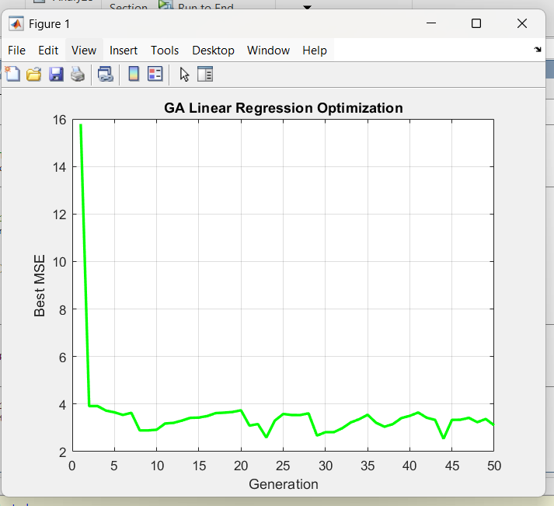

CODE: 4
Knapsack Problem (0–1)
Problem:
Maximize value with weight constraint using binary GA.
clc; clear;

%% Items (weights and values)
weights = [2 3 4 5];
values = [3 4 5 8];
capacity = 5;

popSize = 20;
chromLength = length(weights); % 4 items
pop = round(rand(popSize, chromLength)); % Binary representation
maxGen = 50;
mutRate = 0.05;

bestFitness = zeros(maxGen, 1);

for gen = 1:maxGen
fitness = zeros(popSize, 1);
for i = 1:popSize
totalWeight = sum(pop(i,:) .* weights);
totalValue = sum(pop(i,:) .* values);
if totalWeight <= capacity
fitness(i) = totalValue;
else
fitness(i) = 0; % Penalize overweight
end
end

%% Selection
prob = fitness / sum(fitness + eps);
cumProb = cumsum(prob);
newPop = zeros(size(pop));
for i = 1:popSize
r = rand;
idx = find(cumProb >= r, 1);
newPop(i,:) = pop(idx,:);
end

%% Crossover
for i = 1:2:popSize
if i+1 <= popSize
point = randi(chromLength-1);
newPop([i, i+1], point+1:end) = newPop([i+1, i], point+1:end);
end
end

%% Mutation
for i = 1:popSize
if rand < mutRate
gene = randi(chromLength);
newPop(i, gene) = 1 - newPop(i, gene); % Flip bit
end
end

pop = newPop;
bestFitness(gen) = max(fitness);
end

%% Plot
figure;
plot(1:maxGen, bestFitness, 'm-', 'LineWidth', 2);
xlabel('Generation'); ylabel('Max Value');
title('GA for Knapsack Problem');
grid on;
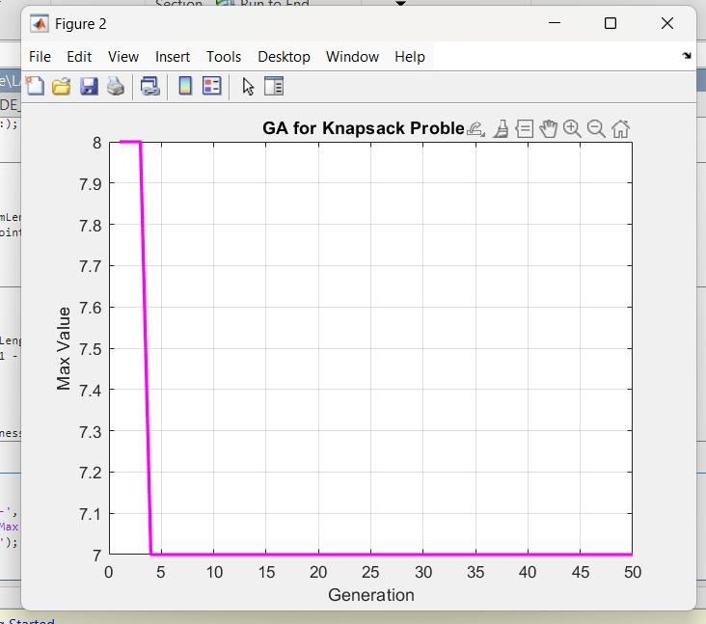

CODE: 5
Find Roots of a Polynomial
Problem:
Find the minimum of f(x) = (x-3)^2 (x+2)^2 in range [-5, 5].
clc; clear; close all;

%% Function with roots at -2 and 3
fitnessFunc = @(x) (x - 3).^2 .* (x + 2).^2;

popSize = 30;
maxGen = 100;
pop = -5 + 10 * rand(popSize, 1); % Range: [-5, 5]
mutRate = 0.1;

bestFitness = zeros(maxGen, 1);

for gen = 1:maxGen
fitness = -fitnessFunc(pop); % Maximize negative of function (minimize original)

%% Selection
prob = fitness - min(fitness) + eps;
prob = prob / sum(prob);
cumProb = cumsum(prob);
newPop = zeros(size(pop));
for i = 1:popSize
r = rand;
idx = find(cumProb >= r, 1);
newPop(i) = pop(idx);
end

%% Crossover
for i = 1:2:popSize
if i+1 <= popSize
alpha = rand;
newPop(i) = alpha * newPop(i) + (1-alpha) * newPop(i+1);
newPop(i+1) = alpha * newPop(i+1) + (1-alpha) * newPop(i);
end
end

%% Mutation
for i = 1:popSize
if rand < mutRate
newPop(i) = newPop(i) + 0.5 * randn;
newPop(i) = max(-5, min(5, newPop(i)));
end
end

pop = newPop;
bestFitness(gen) = min(fitnessFunc(pop));
end

%% Plot
figure;
plot(1:maxGen, bestFitness, 'k-', 'LineWidth', 2);
xlabel('Generation'); ylabel('Best f(x)');
title('GA: Find Minimum of (x-3)^2(x+2)^2');
grid on;
